ASSIGNMENT SUBMISSION COVER SHEET

CSE25-297
Student Id:

AOBAKWE MATHULE
Student names:

CSE25-297@thuto.bac.ac.bw
Student email:

CSE 1-5 2026

Cohort:

SCIS WMD_2026 A01
Assignment title:

05/19/2026
Date of submission:

BSC COMPUTER SYSYTEMS ENGINEERING
Programme of Study:

2026
Year of Study:

Intellectual property statement
By checking the box below, I certify that this assignment is my own work and is free from plagiarism. I understand that the assignment may be checked for plagiarism by electronic or other means and may be transferred and stored in a database for the purposes of data-matching to help detect plagiarism. The assignment has not previously been submitted for assessment in any other unit or to any other institution. I have read and understood the Botswana Accountancy College plagiarism guidelines policy.
☐ Agree Signature A.Mathule
Date 05/19/2026

SLANGFIELD DOCUMENTATION
Slangfield landscape Services website provides Borehole drilling, Fencing Machinery rental and site analysis services to its clients.
Website Specifications
Website Objective
The primary objective of the SlangField Landscape Services website is to establish a professional online presence that effectively showcases the company's land development services to potential clients. The website serves as a comprehensive digital brochure that communicates the company's expertise in fencing, borehole drilling, machinery rental, and site analysis services.
GOALS
- The website is designed to achieve the following strategic goals for the business:
- Generate qualified leads through the contact form and service inquiry system
- Build brand credibility by showcasing completed projects and client testimonials
- Provide detailed information about services to reduce customer inquiry time
- Establish trust through professional design and comprehensive company information
- Enable 24/7 accessibility to company information and contact details
Target Audience
The website is designed to cater to a diverse audience with varying needs and technical capabilities. Understanding the target audience is crucial for creating an effective user experience that meets their expectations and facilitates conversion.

PRIMARY TARGET AUDIENCE

 | Demographics | Technical aptitude
Farm Owners | Mostly aged from 35 to 65 years, based at rural areas, have Agricultural background with medium to large land holdings. | Basic to intermediate, uses mobile devices frequently.
Property Developers | Aged between 30 to 55 years, found in Urban and semi-Urban areas. They are business professionals with multiple property investments. | Intermediate to advanced, expect professional design, uses desktops primarily with the mixture of mobile devices
Rural communities | Age varies widely, based on remote locations, Community-focused, Borehole and water needs. | Prefers local language, limited internet access,  Mobile device users
Construction Company | Aged between 25-50 years, Commercial focus, Industry experience, Project-based needs | Intermediate, seeks detailed specifications, Compares services efficiently

Type Of Website
SlangField Landscape Services website is classified as a corporate business website with services portfolio functionality. It falls under the category of informational and lead-generation websites, designed to present company information and converts visitors into potential clients.

INFORMATION DESING & TAXONOMY
Information Architecture
The website follows a hierarchical information architecture that organizes content into logical categories. This structure ensures that users can find information efficiently within three clicks, following the standard web usability guideline. The architecture is designed to guide users from general information to specific details progressively.
Website pages:
- Home (services overview, statistics, testimonials)
- About (Detailed service descriptions with images and features)
- Services (Company story, mission, vision, team, credentials)
- Gallery (Project portfolio with filter, client testimonials)
- About (Contact form, company info, map placeholder, social links)

SITE MAP STRUCTURE
├Home
├Services
├Gallery
├About
├contact
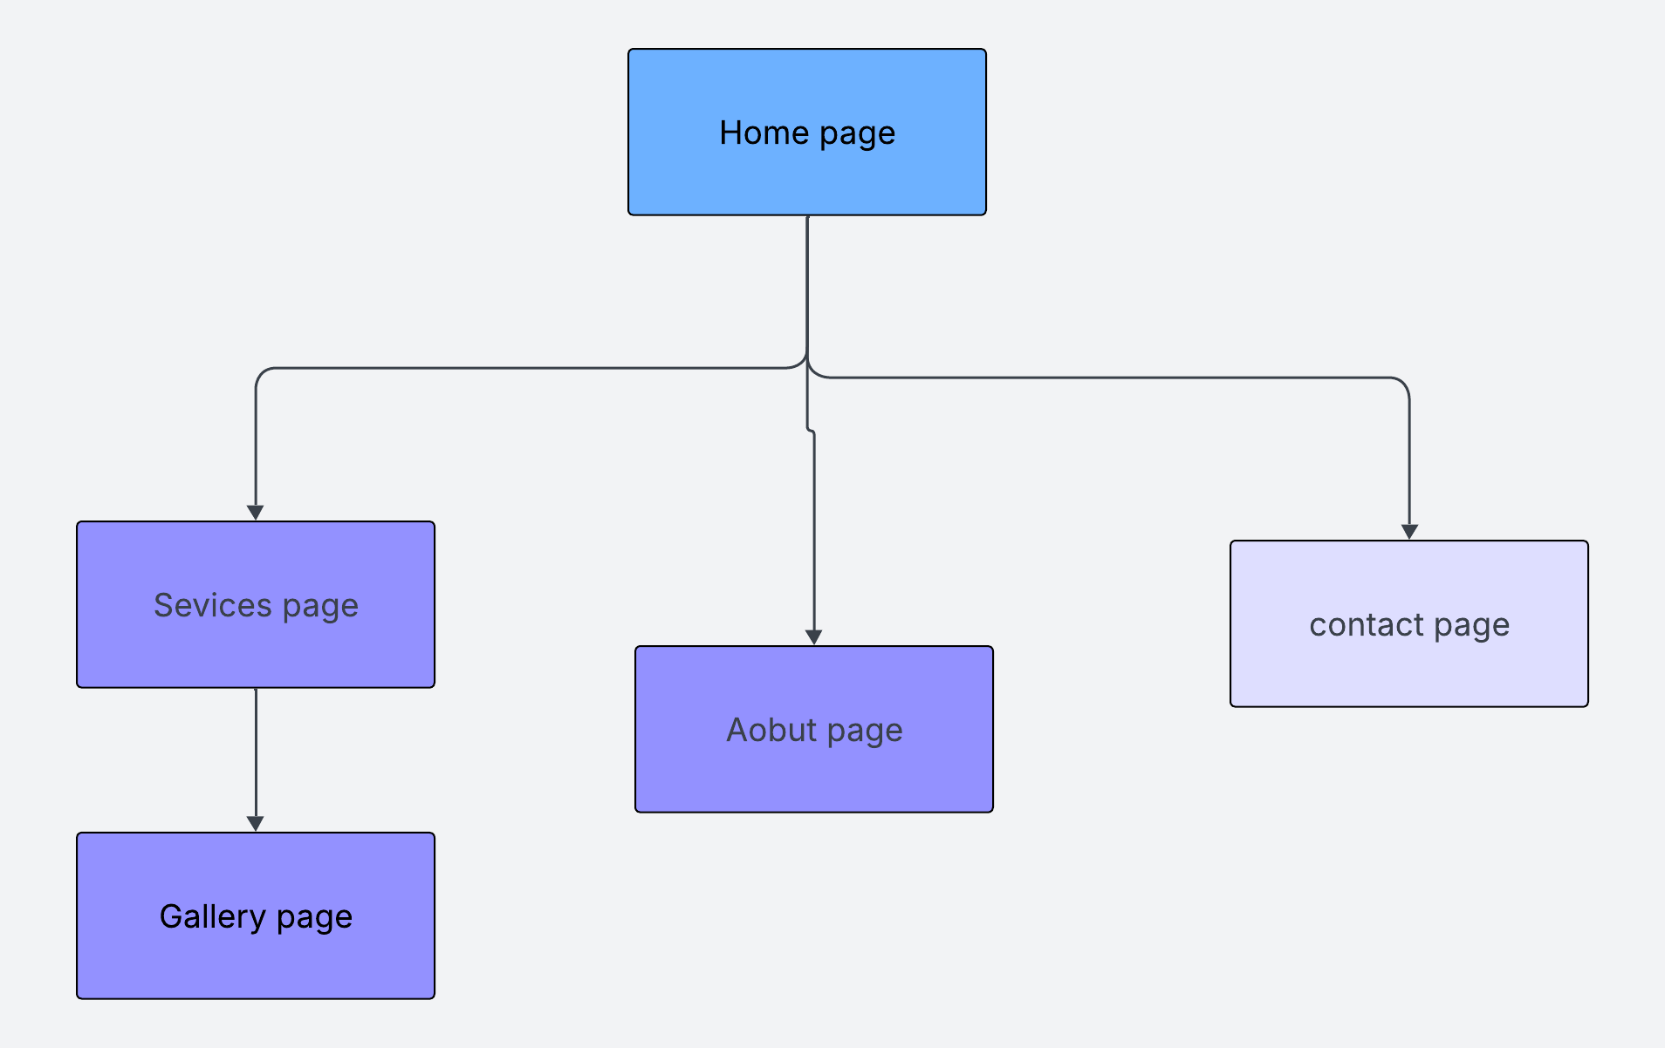
CONTENT TAXONOMY
Content is organized into a hierarchical taxonomy that categorizes information by type and purpose. This classification system ensures consistent organization across all pages and helps users understand the relationship between different content elements.
Home- Company details and website introduction of what the website provides.
Services- Borehole drilling, Fencing Machinery rental and site analysis, Project description,
Gallery- All projects that the company has made, and customer testimonials
About - Vision, About us and mission statement.
Contact-contact form, address, phone numbers, emails and working hours.

SLANGFIELD PAGE TEMPLATE
This document is to give a guideline on how the website pages will look like.
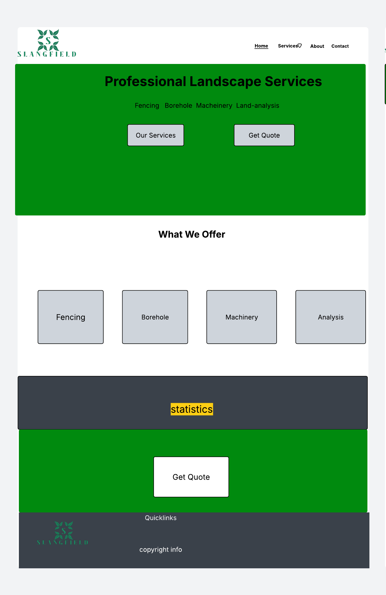
HOME PAGE TEMPLATE

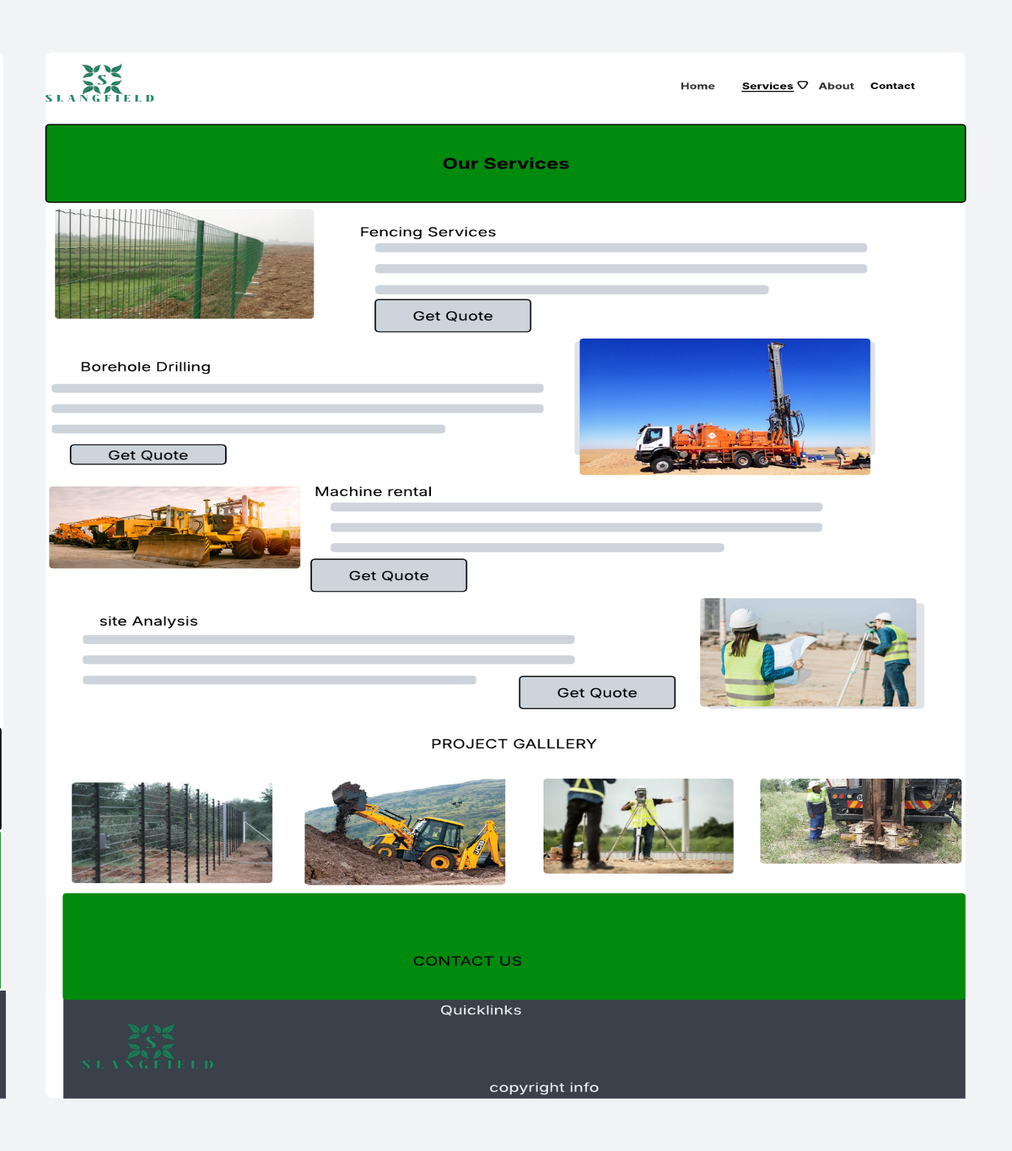
SERVICE PAGE TEMPLATE

ABOUT PAGE TEMPLATE
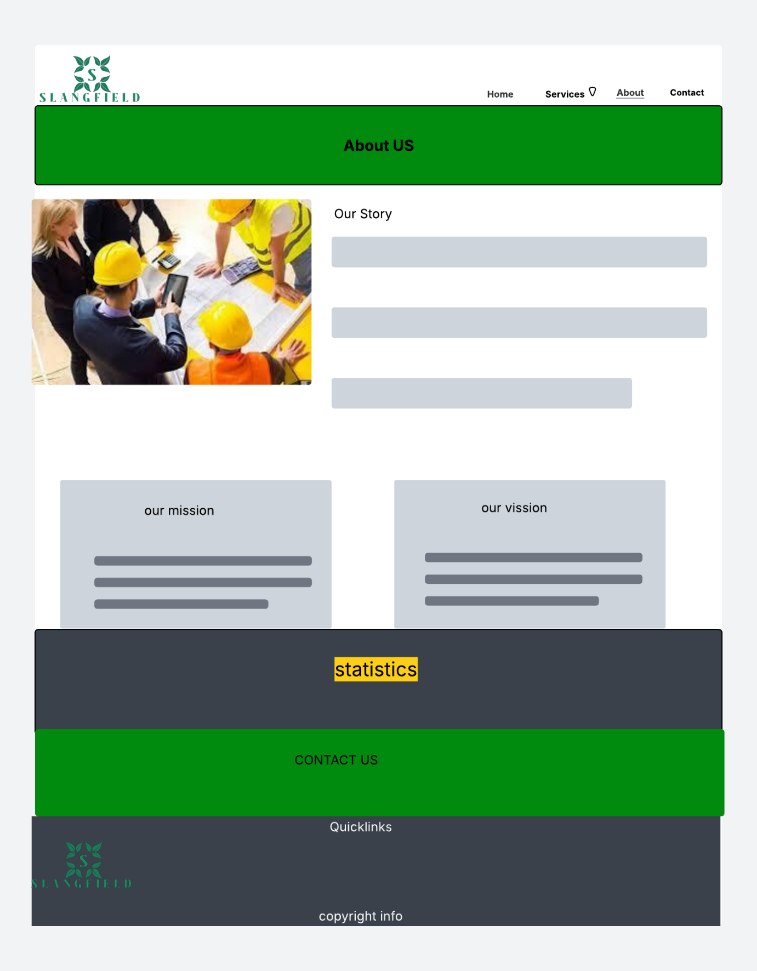

CONTACT PAGE TEMPLATE
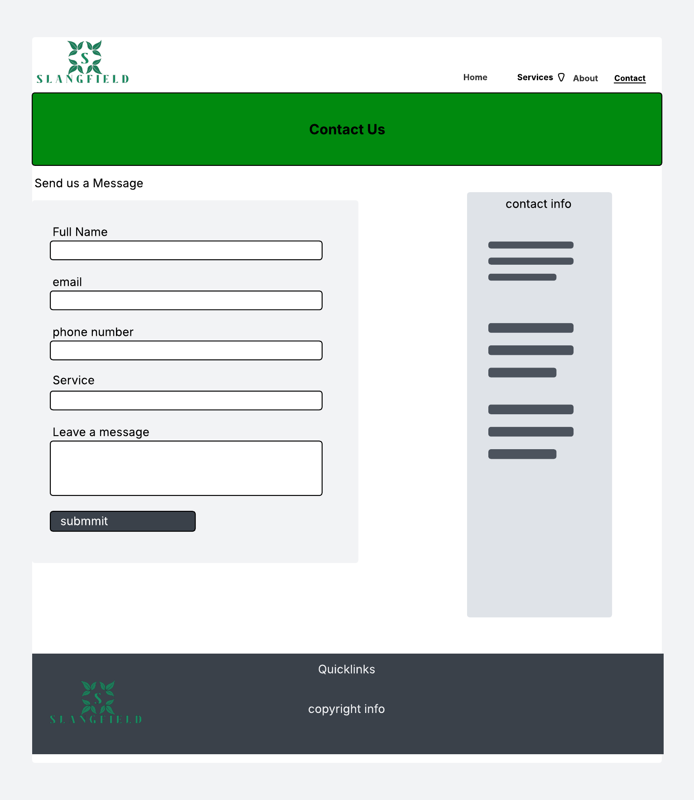

TECHNICAL BRIEF
Technologies used
The website is built using fundamental web technologies that ensure broad compatibility and ease of maintenance. The decision to use core technologies rather than frameworks was made to demonstrate a solid understanding of web development principles, which is essential for first-year students learning the foundations of web development.
- HTML5 -used for page structure, form elements and accessibility features
- JAVASCRIPT - Used for form validation, and interactivity of webpages.
- CSS3 -Styling, responsive design and layouts for webpages.
- Bootstrap 5.3- Frontend framework for responsive grid layout and components.

SOFTWARE TOOLS AND RESOURCES
Various software tools were utilized throughout the development process to create, edit, and test the website. These tools were selected based on industry standards and educational appropriateness for first-year students.
Development Tools
- Visual Studio Code: Primary code editor for writing HTML, CSS, and JavaScript files with syntax highlighting and live preview
- Google Chrome DevTools: Browser-based debugging and responsive design testing across multiple screen sizes
- GitHub/GitHub Pages: Version control and free web hosting for the live website deployment
Graphics and Design Tools
- GIMP: Image editing for creating and optimizing website graphics, logos, and banners
- Wireframe Tools: Planning and documenting page layouts before development
- Pinterest: for images to use on the website.

References
- W3Schools for javaScript tutorial : https://www.w3schools.com/js/:
- Web fundamentals, responsive web design basics : https://developers.google.com/articles/usability-101-introduction-to-usability/
- W3C web Accessibility initiative. Web Accessibility Tutorials : https://www.w3.org/WAI/tutorials/
- Bootstrap documentation. Get started With Bootstrap 5.3 : https://getbootstrap.com/docs/5.3/getting-started/

QUALITY ASSURANCE
This where i will show the results of the testing conducted on Slangfield Landscape Services website. The testing was conducted to make sure the site supports different browsers and is responsive on mobile devices.

Testing Overview
This are the categories of testing done:
- Browser Compatibility- to make sure the site is supported and works well with different browsers.
- Mobile Device – test if the site is responsive on different phones and screen sizes of different operating systems.
- Functionality- check the contact form, navigation links if they work

Browser Compatibility Tests
Browser | Description | Result
Google chrome | All pages load up fine and the navigation links are perfectly functioning | Pass
Microsoft Edge | Just like chrome the pages fully render. | Pass
Opera Gx | There is a bit of a flex-gap but its hard to identify so all is good. | pass

Screenshots
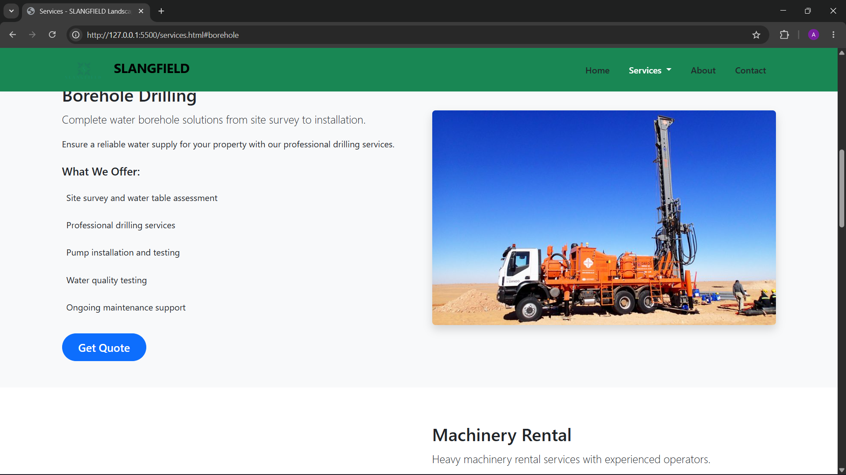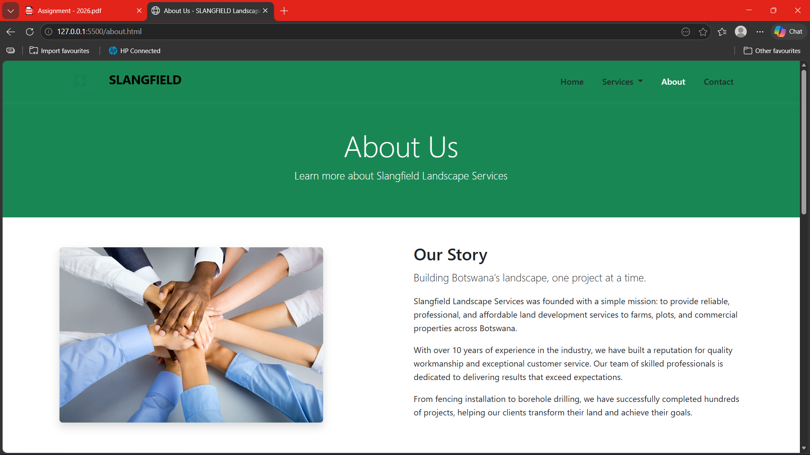

Mobile Device test
Device | Observation | Result
iPhone x (ios14) | Smooth scrolling pages load perfectly, slight increase on margins | pass
Google pixel 1 | Dropdown menu works fine all navigation links too | pass

Screenshots
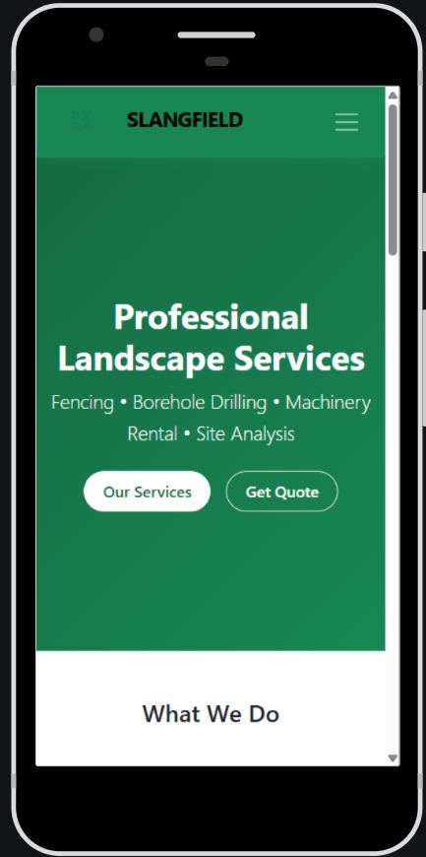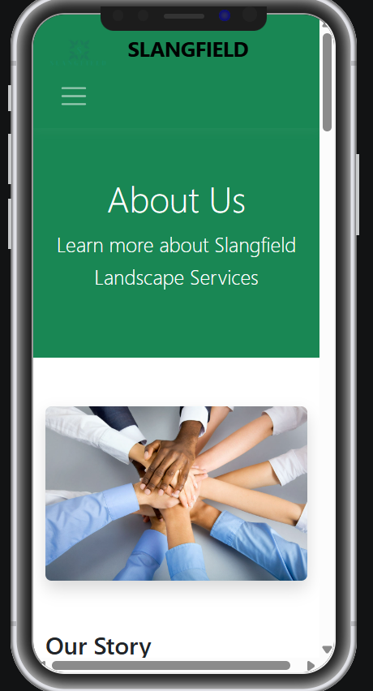

FUNCTIONAL TESTING
Check were performed across different browsers to see if this function work.
- Contact form, It required field validation to stop submission of an empty form.
- Navigation links ,made sure that the links work and take the user to the right destination.
- Footer links, quick links in the footer section all working correctly.
- Action Buttons, the send form and get quote buttons were tested.

PUBLISHING AND PROMOTION
Hosting Platform
Slangfield Landscape Services website is hosted in GitHub pages, which is a free site hosting service provided by GitHub. The files of the pages are directly stored in repository.
- Repsoitory: https://github.com/cse25-297/cse25-297
- Live website URL: https://cse25-297.github.io/cse25-297/
- Branch used for deployment: main
- Hosting method: GitHub Pages – deployed from root of the main branch

Tools Used
Visual Studio Code: Primary code editor for writing HTML, CSS, and JavaScript files with syntax highlighting and live preview.
GitHub/GitHub Pages: Version control and free web hosting for the live website deployment.

Repository Initialisation
This are the git commands used to initialise the local repository and connect to the remote GitHub repository.
- git init- it initialises a new local repository on the project folder.
- git remote add origin https://github.com/cse25-297/cse25-297.git- this connected the local repository to the remote GitHub repository.

The commands i used throughout the website development are:
- git status- to review the files that were modified, stage and left untracked.
- git add.- this add a new file to the repository that is in the project folder.
- git commit -m: shows an update made to the files.
- git push origin main- Pushes the committed changes to the main branch of the remote GitHub repository from the local one.

PROMOTION
These are the promotion strategies I would use for promoting the website.
- Sharing the website on social media like Facebook and WhatsApp that are commonly used.
- Sharing the link with potential clients to review
- Putting the website on the company business cards and flyers.

FUTURE DEVELOPMENTS
- Online Quote System, that would allow for clients to select the a service and the plot size to receive an estimated cost of service instantly.
- WhatsApp Chat integration, As WhatsApp is a primary tool for business communication a WhatsApp chat button can be introduced to the site to allow for clients to directly contact the company without filling up the form.
- Client Testimonial, a section where clients can share their reviews of how the services was which ca build trust with prospective customers.
- Multilingual Support, addition of other languages especially local once to accommodate for potential customers.

